11th ANNUAL

HOUSEHOLD HAZARDOUS
WASTE COLLECTION &
PAPER SHREDDING EVENT
Saturday, NOVEMBER 16, 2019
10:00 am to 2:00 pm at PINECREST HIGH SCHOOL
(Parking lot off of Volt Gilmore Lane)

PLEASE NOTE: KEEP MOORE COUNTY BEAUTIFUL
PAPER SHREDDING EVENT WILL BE SEPARATE AT THE LOWER SMALLER PARKING LOT

MOORE COUNTY RESIDENTS ONLY commercial and electronic waste WILL NOT be accepted. However, you may dispose of E-Waste at Moore County Collection Centers.

EXAMPLES OF ITEMS TO BE COLLECTED ARE:
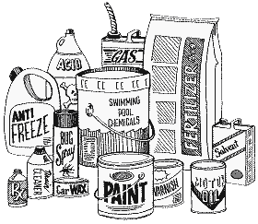
Paint and paint thinners, furniture strippers
& finishing products, solvents & degreasers,
wood preservatives, polishes, aerosols,
fluorescent light tubes, compact fluorescent
bulbs, NiCad batteries, alkaline batteries,
lithium batteries, propane cylinders, swimming
pool chemicals, used motor oil, antifreeze,
gasoline, hydraulic transmission & brake fluid.

Pesticides, herbicides, fungicides and insecticides will be accepted but MUST be in its original containers for identification purposes.
This event is sponsored by: Moore County Cooperative Extension Service, Keep Moore County Beautiful, County of Moore, Village of Pinehurst, Village of Whispering Pines, N.C. Dept. of Agriculture, the Town of Aberdeen, the Town of Southern Pines and the NCDA & CS Pesticide Disposal Assistance Program.

